Project Proposal

First three rooms and a mini boss of a metroidvania

Game Reference:

Art Style:

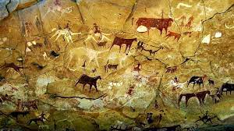

Hollow Knight

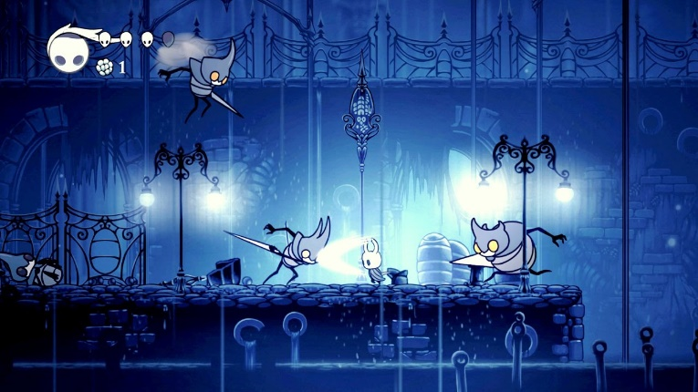

Blasphemous

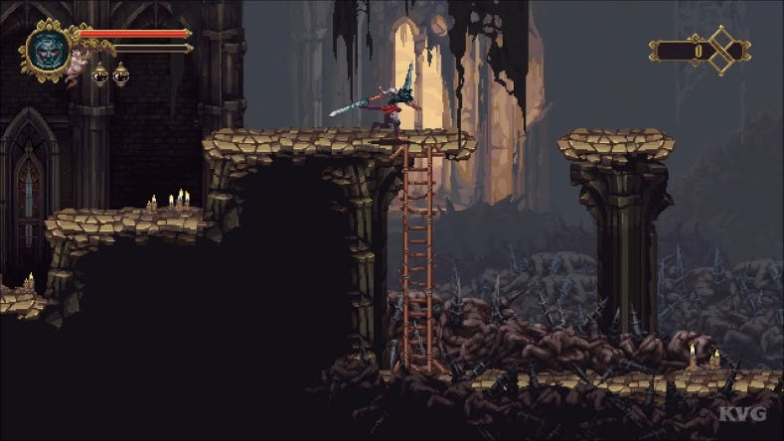

Octopath Traveler

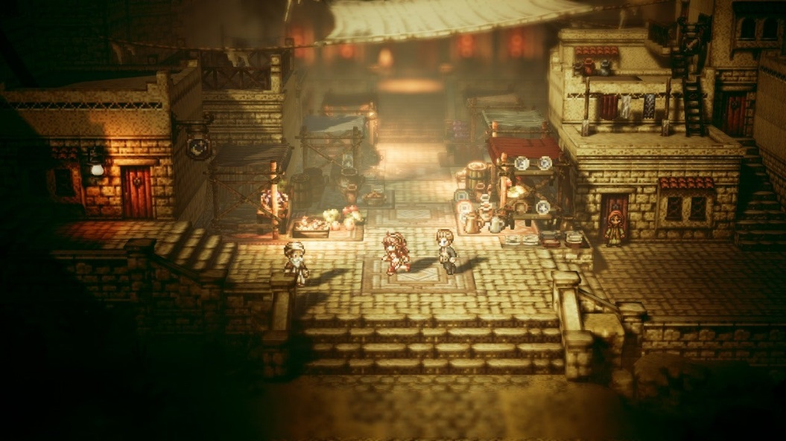

Engine: Unity

Game Features:

4 Rooms to play through,

1 starting room and 2 rooms with platforming challenges,

1 room with the mini boss,

Basic AI for enemies and mini boss,

Satisfying Combat,

Shaders and Post Processing effects

Assets Needed:

Sprite Sheets: Player, 2 Basic Enemies, Mini-Boss

Sprites/Models: Walls, Floors, Doors, Decorations, Background

Audio: Footsteps, Attacking, Damage, Jumping, Music